**Visvesvaraya Technological University,Belgavi**

**Government Engineering College, Hassan - 573201**



Mini Project Report On

**“Cyber Cafe Management System”**

Submitted in partial fulfilment of fifth semester Database Management System

LABORATORY WITH MINI PROJECT (18CSL58) in Computer Science and Engineering.

Under the guidance of:

Mr. Annaiah H, B.E, M.Tech,MISTE

Assistant Professor

Dept. of Computer Science & Engineering

Government Engineering College, Hassan

Mrs. CHANDANA H M, B.E, MTech

Assistant Professor

Dept. of Computer Science & Engineering

Government Engineering College, Hassan

Submitted by

Jayanth Kumar S (4GH18CS011)

Jeethendra S R (4GH18CS012)

Department of Computer Science & Engineering

Government Engineering College, Hassan

**DEPARTMENT OF COMPUTER SCIENCE AND**

**ENGINEERING**

**GOVERNMENT ENGINEERING COLLEGE, HASSAN**



**2020 - 2021**

**CERTIFICATE**

This is to certify that **Mr. JAYANTH KUMAR S, USN:4GH18CS011**and **Mr.JEETHENDRA S R, USN:4GH18CS012** has satisfactorily implemented the mini project titled “**CYBER CAFE MANAGEMENT SYSTEM”** in fifth semester DBMS Laboratory with mini project (18CSL58) as per the requirements of **Visvesvaraya Technological University, Belagavi** for the academic year 2020-2021.

**Mrs. CHANDANA H M,** B.E, M.Tech **Mr. Raghu M E,** B.E, M.Tech, PhD **Mr. Annaiah H,** B.E, M.Tech,MISTE

Assistant Professor, Head of Department, Assistant Professor,

Dept. Of CS&E., Dept. Of CS&E., Dept. Of CS&E.,

GEC, Hassan. GEC, Hassan. GEC, Hassan.

**External Viva**

**Name and Signature of Examiner with Date**

**1.**

**2.**

**DECLARATION**

We, **JAYANTH KUMAR S** and **JEETHENDRA S R** students of fifth semester B.E**, GOVERNMENT ENGINEERING COLLEGE, Hassan** bearing USN **4GH18CS011** and **4GH18CS012** respectively, hereby declare that the project entitled “**CYBER CAFE MANAGEMENT SYSTEM”** has been carried out by us under the supervision of our Guide, **Mr. ANNAIAH H,** B.E., M.Tech, MISTE, Assistant Professor, Dept. of CS&E, GEC Hassan and **Ms. CHANDANA H M,** B.E., M.Tech, Assistant Professor, Dept. of CS&E, GEC Hassan, have submitted in partial fulfilment of the requirements for the award of the Degree of B.E in CS&E by the Visvesvaraya Technological University, Belgavi during the academic year 2019-2020. This report has not been submitted to any other Organization/University for the award of degree or certificate.

**Project associates Date:**

Jayanth Kumar S **Place :** Hassan

Jeethendra S R

**ACKNOWLEDGEMENT**

The completion of any project involves the efforts of many people. We have been lucky to have received a lot of help and support from all directions during the making of this project, so with gratitude we take this opportunity to acknowledge all those whose guidance and

encouragement helped us to emerge successful.

We express our heartiest gratitude to our Principal, **Dr. K. C Ravishankar**, B.E., M.Tech, PhD for creating an excellent and technically sound environment in our institution.

We are deeply indebted to Professor and Head of Department, **Dr. Raghu M E**, B.E, M.Tech, PhD and all the staff of DEPT. of CS&E for their constant guidance and encouragement.

We would like to express our profound sense of gratitude to our guide **Mr. Annaiah H**, B.E, M.Tech, MISTE Assistant Professor, Dept. of CS&E for his kind guidance. We are grateful for his help in the preparation of this manuscript.

It is a great pleasure to acknowledge our sincere gratitude to **Mrs. Chandana H M**, B.E, M.Tech, Assistant Professor, Dept. of CS&E for her help and encouragement rendered towards the successful completion of the mini project work.

We are grateful to our institution GOVERNMENT ENGINEERING COLLEGE, HASSAN and DEPARTMENT OF COMPUTER SCIENCE AND ENGINEERING for imparting us the knowledge with which we can do our best.

We thank to all the teaching, non-teaching and technical supporting staff of Department of Computer Science and Engineering and Government Engineering College, Hassan who have helped us on various occasions during the course of this work.

**Project Associates**

Jayanth Kumar S

Jeethendra S R

**CHAPTER 1**

**INTRODUCTION**

* 1. **BACKGROUND**

Computers have become a way of life for today’s high society. Many aspects of modern life that we have to accept as common place would not be possible if there were no computers.Today computers are used extensively in many areas of business, science, education etc. The major advantage of computer is its speed that makes it able to give some useful information very quickly. Another feature is its accuracy.

This project is intended to be used in Cyber Cafe. All cyber cafes have some basic needs likeable to control the systems that are being rented to the customers and are charged on timely basis.This project only have server part which runs on Admin system .

The Admin should have control over the usage of the client system and keep track of what the client is doing. Computers can hold data and instruction in an electronic representation in internal memory and this data can be retrieved at any time.

**1.2 PROBLEM STATEMENT**

In existing system a lot of manual work has to be carried out. Large amount of paper work is involved which may cause high degree of error. Registration of user names, keeping records of user are done manually, which is time-consuming process and there is possibility of making errors.

Administrator has to keep the track of time, which is tedious job. Once the user logs out, while preparing bill, he has referred to user details including name, login time and time allocated leading to possibility of causing errors in bill calculation. This may be non-beneficial to administrator.

Also a lot of files, records are required to store these documents thus making it difficult to maintain. Since all these reports are prepared manually, we require computer software for all these purposes.

Hence also there is not accuracy in bill calculations.

* 1. **SOLUTION**

The project entitled “Cyber Cafe Management System” is a software package, which can be used in cyber cafes for managing the clients and billing.

As this is automated cyber management system it makes it very easy for administrator to search details. Also the time allotment is done very efficiently and it provides fast service in term of the bill calculation and time management.

In this system admin can briefly view total number of user come in cyber cafe, add new users, update out-time, price and remarks, and view details of old users.

Its major advantage is that it records the type of terminals accessed by the customers and full details of the customers are recorded in the database so that if any enquiry is needed by anyone later it can be systematically done.It works the admin front so user cannot manipulate or access any part of the information in the system.

* 1. **OBJECTIVE**
* The aim of our project is to replace the paper works & works done manually and to automate the existing trend in the cyber cafe. Be it user creation, their management or bill generation, everything is computerized.Since the admin job is done effortlessly.
* To keep the track of time and user details including name, login time and time allocated efficiently.
* To maintain and store files, record and documents in the internal memory and retrieve whenever required.
* It makes it very easy for administrator to search details. Also time allotment is done very efficiently and it provides fast service in term of the bill calculation and time management.

**CHAPTER 2**

**SYSTEM REQUIREMENT SPECIFICATION**

**2.1 FUNCTIONAL REQUIREMENT SPECIFICATION**

Functional requirements are related to the system behaviour only for the certain inputs that should satisfy. They are linked to the expectations from the intended software. They are also called as product features.

**2.1.1 CREATING ACCOUNT**

**Description:**

This will make the account for the user which will be required to login whenever the user will open the software.

**Response Status:**

It will check if the length of the username cross the specified limit, if so it will display error.

**2.1.2 CREATE LOGIN INTERFACE**

**Description:**

Create a login interface which provide authentication to the valid owner to access the other informations.

**Response Status:**

If the entered username or password is not in database it will reload the same page. It will open the next interface if the login credentials are correct.

**2.1.3 INPUT SYSTEM INFORMTION**

**Description:**

Ask owner to provide necessary system information for the system to operate further.

**Response Status:**

Store the entered system information in the database.

**2.1.4 SHOW SYSTEM INFORMATION**

**Description:** Show the user the system information.

**Response Status:**

No response as there is no input just it will display the informations.

**2.1.5 ENTER CUSTOMER INFORMATION**

**Description:**

Ask the user the works it want to perform in café and what are his requirements.

**Response Status:**

Record the requirements in the database.

**2.1.6 VIEW CUSTOMER INFORMATION**

**Description:**

Show the user the information about the customers who have visited till now.

**Response Status:**

No response as there is no input.

**2.1.7 CHECKOUT**

**Description:**

To provide the bill after the out-time of the customer.

**Response Status:**

It provides with the bill calculation after checking out.

**2.2 NON-FUNCTIONAL REQUIREMENT SPECIFICATION**

* **Performance Requirements:** The primary performance requirement is processor speed and its better data parallelism hardware support. More the core better will be system performance. Intel coreI7 and Intel coreI5 are recommendable.
* **Safety Requirements:** There are no safety requirements with this application, other than any normal hazards of password disclosure.
* **Security Requirements:** The data of the users who have visisted the shop which is stored in the database should not be disclosed with anyone except the investigating autority with permission.This is important for the user privacy.The system should withstand any cyber attack if done.
* **Maintainability:** The software should provide the ease to change the data on which it operate like it has been mentioned in functional requirements that there should be a function to change the system information like rates etc.
* **Adaptability:** The system should inform the user if he tries to enter any value which is not practically possible because that might be any logical or typing error.

**2.3. SYSTEM REQUIREMENTS**

System requirements are expressed in software requirement document. It is the official statement

for what is required for the system developers. Requirement document include the requirement definition

and requirement definitions user requirement specification.

The software requirement document is not designed document. It should set out what the system should

do without specifying how it should be done.

1. Storing the information of the components and events in the customized database.

2. Accessing information of the components.

3. Making queries for modifying component and event details.

**2.3.1 HARDWARE REQUIREMENTS**

**Processor :** Intel core3 processor and above.

**RAM :** 4GB and more.

**Hard disk :** 16GB and more.

**2.3.2 SOFTWARE REQUIREMENTS**

1. XAMPP

2. HTML

3. CSS

4. PYTHON AND DJANGO

**XAMPP:**

The full form of XAMPP stands for Cross platform, Apache, MariaDB (Mysql), PHP and Perl.

**HTML:**

HTML stands for hypertext mark-up language, which is the most widely used language on web

develop web pages.

**CSS:**

Cascading Style Sheets is a style sheet language used for describing the presentation of a document written in a mark-up language like HTML.

**PYTHON AND DJANGO:**

Python is known for its general-purpose nature that makes it applicable in almost every domain of software development. Python makes its presence in every emerging field. Django is an one of the most popular web framework. Django is versatile in nature which allows it to build applications for different-different domains.

**CHAPTER 3**

**SYSTEM DESIGN**

**3.1 DESIGN DIAGRAM**

Design diagram helps to identify the essential components of an Event details management system

like events, components, facilities, teams, registration, achievements.

**3.1.1 DATAFLOW DIAGRAM (DFD)**

Computer Management

Usage

Management

Customer

Management

Cybercafe management system

Bill / Charge

Management

Profile

Management

ID Proof

Management

* A dataflow diagram is a graphical view of data is processed in a system in terms of input and output.
* The dataflow diagram(DFD) contains some symbol for drawing the data flow diagram.
* The fig shows the neccessary elemental actions performed in the Cyber Cafe Management System.

**3.1.2 SYSTEM ARCHITECTURE**

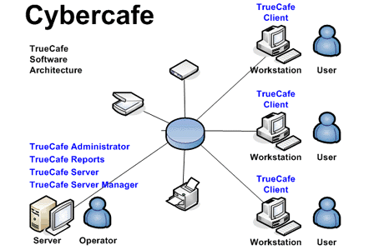

* The basic client/server architecture is used to deal with a large number of PCs, web servers, database servers and other components that are connected with netwoks.
* The client /server architecture consists of manry PCs and workstation which are connected via the network.

**3.1.2 ER DIAGRAM**

An Entity Relationship Model (ERM) in software engineering is an abstract and conceptual representation of data. Entity Relationship modelling is a relational schema database modelling method, used to produce a type of conceptual schema or semantic data model of a system, often a relation database, and its requirements in a top-down fashion. An Entity-Relationship Diagram (ER Diagram) is a specialized graphics that illustrates the interrelationship between entities in a database. ER Diagrams often use symbols to represent three different types of information. Boxes are used to represent ‘Entities’. Diamonds normally represents the ‘Relationship’ and Ovals are used to represent ‘Attributes’.

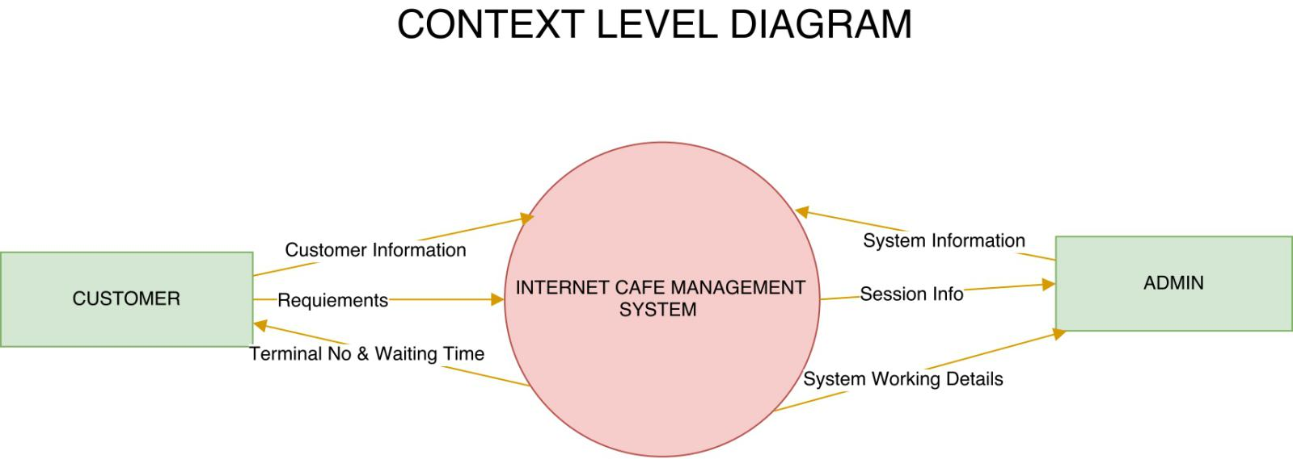

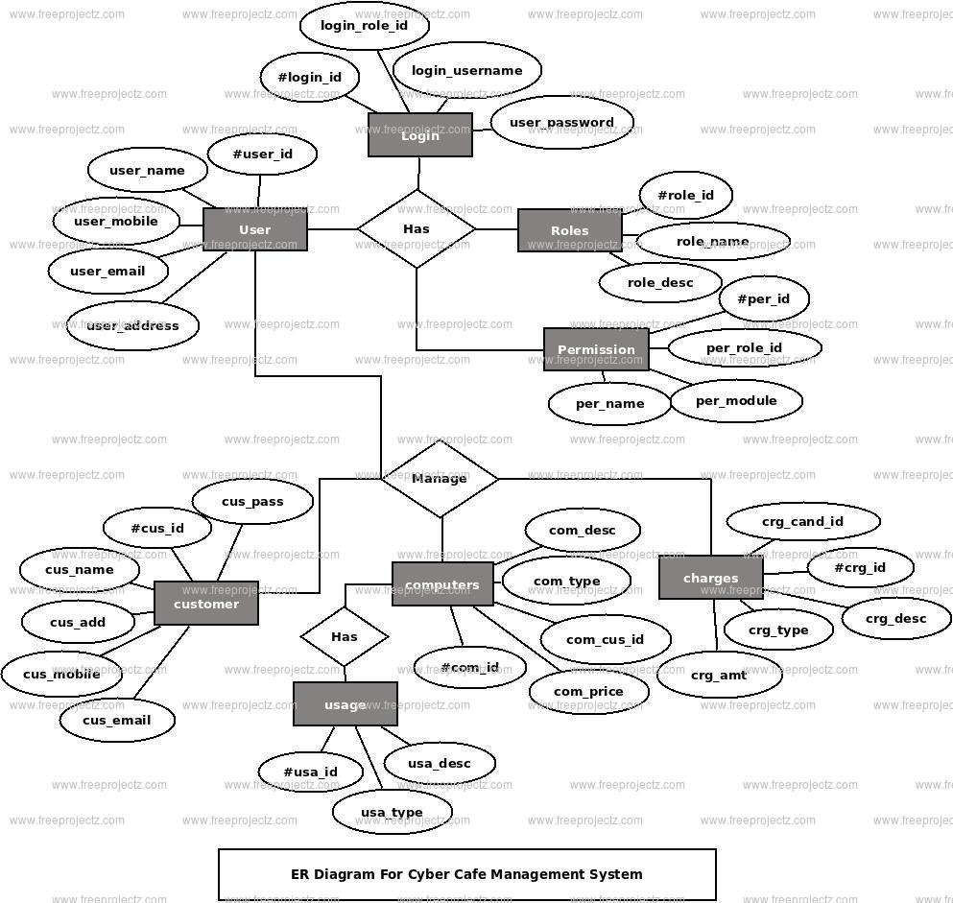

**CHAPTER 4**

**IMPLEMENTATION**

**4.1 LANGUAGE USED**

**Python with Django**

Python is known for its general-purpose nature that makes it applicable in almost every domain of software development. Python makes its presence in every emerging field. It is the fastest-growing programming language and can develop any application.

We can use Python to develop web applications. It provides libraries to handle internet protocols such as HTML and XML, JSON, Email processing, request, beautifulSoup, Feedparser, etc. One of Python web-framework named Django is used on **Instagram**.

Django is an one of the most popular web framework. It has widely supportive community and channels to share and connect. Django is versatile in nature which allows it to build applications for different-different domains. Now a days, Companies are using Django to build various types of applications like: content management systems, social networks sites or scientific computing platforms etc.

**4.2 PLATFORM**

**4.2.1 UBUNTU PLATFORM**

Ubuntu is a free and open-source operating system and Linux distribution based on Debian.

Ubuntu is offered in three official editions: Ubuntu Desktop for personal computers, Ubuntu

server for server and the cloud, and Ubuntu core for internet of things devices and robots. New

releases of Ubuntu occur every six months, while long-term support releases occur every two

years, and the most recent one is, 20.04 LTS.

**XAMPP**

X-Cross-platform enable us the use on different types of computer or with different software

packages.

A-Apache is open-source cross-platform web server software that allows website owners to

serve content on the web and hence the name Apache “web server”..

M- MariaDB is a community-developed fork of the MySQL relational database management

system. MySQL is an Oracle-backed open source relational database management system

(RDBMS) based on Structured Query Language (SQL).

**4.3 TRIGGERS**

MySQL trigger is a named database object which is associated with a table and it activates when

a particular event (e.g. an insert, update or delete) occurs for the table.

CREATE TRIGGER creates a new trigger in MySQL. Also learn tools to create MySQL Triggers,

Example on AFTER INSERT, BEFORE INSERT, AFTER UPDATE, AFTER

DELETE triggers.

**4.4 STORED PROCEDURES**

Stored procedure is a procedure in SQL stored in a database which can be called by database

engine and connected programs. Stored procedures may return result sets that are the results of a

SELECT statement. Such result sets can be processed using cursors, by other stored procedures,

by associating a result–set locater, or by applications. Stored procedures may also contain declare

variables for processing data and cursors that allow it to loop through multiple rows in a table.

**4.5 MODULES**

1. Dashboard
2. Computer
3. User
4. Search
5. Profile
6. Change Password
7. Logout

**4.5.1 MODULE DESCRIPTION**

1. **Dashboard:** In this section admin can briefly view total number of computers and total number of user come in cyber cafe.
2. **Computer:** In this section, admin can manage the computers(add/update).
3. **Users:** In this section, admin can add new users, update outime, price and remarks, and view details of old users.
4. **Search:** In this section admin can search users on the basis of entry id.
5. **Profile:** In this section admin can update his/her profile.
6. **Change Password:** In this section admin can change his/her passwords.
7. **Logout:** Through this button admin can logout.

**CHAPTER 5**

**IMPLEMENTATION OF RESULTS**

**5.1 SNAPSHOTS**

**Admin Login Page**

A login, logging in or logging on is the entering of identifier information into a system by a user in order to access that system (e.g., a computer or a website). It is an integral part of computer security procedures. A login generally requires the user to enter two pieces of information, first a user name and then a password.

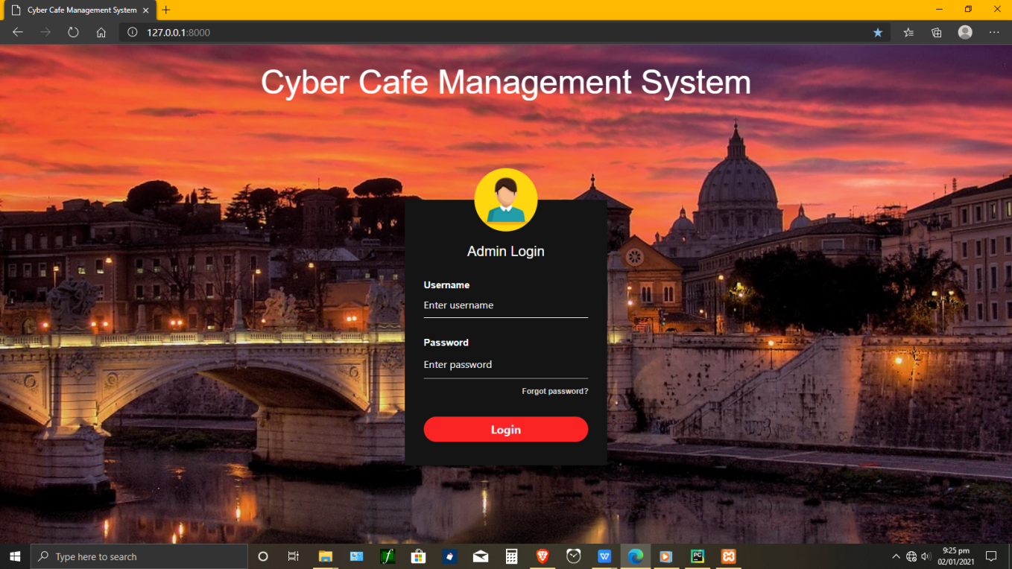

Here, The user has to login with the username and password that was given previously while creating an Account.

**Dashboard**

a dashboard is a user interface that, somewhat resembling an automobile's dashboard, organizes and presents information in a way that is easy to read. However, a computer dashboard is more likely to be interactive than an automobile dashboard.

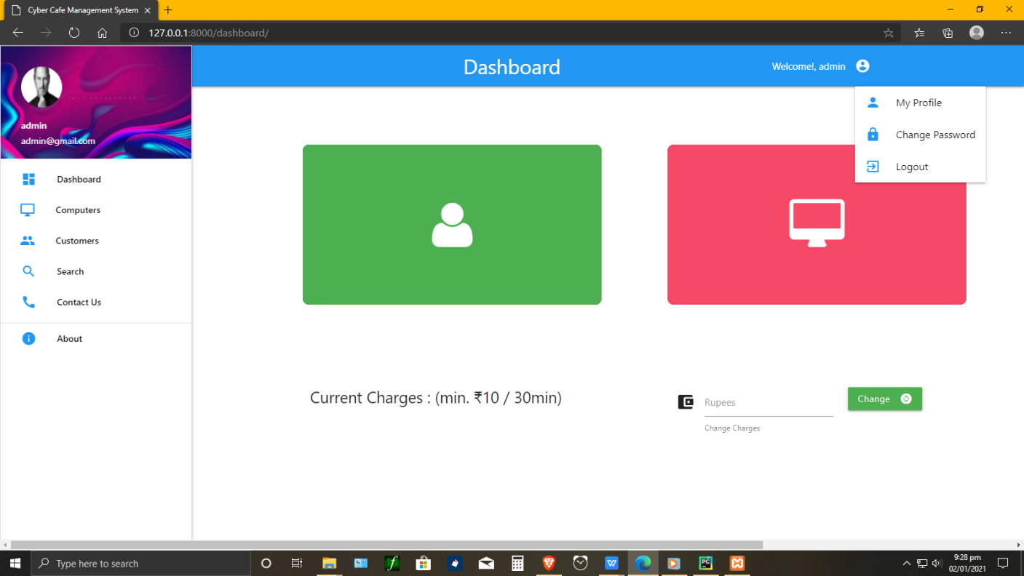

The Dashboard contains all the neccesary modules in one place. Thus, it makes it easy for the admin/user to perform his/her tasks easily and efficiently.

**Computer Section**

**Add Computer**

This page allows admin to add computers and computer’s location to check the occupied and vacant cabin for users.

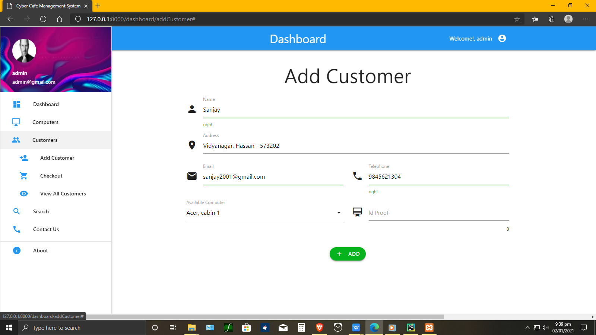

**Manage Computer**

This page will allow admins to add/delete the computer’s information, computer location and computer’s name.

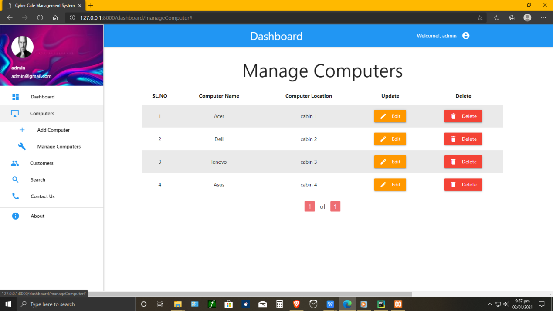

**Customer Section**

**Add Customer**

This page is used to add the customer’s information entering the cyber cafe. The information such customer’s name, Address, Email, Phone number and Id Proof. The particular customer’s cabin is also allocated in this page in Available Computer.



**View All Customers**

It stores imformation on all the customers entering the Cyber cafe and their details.

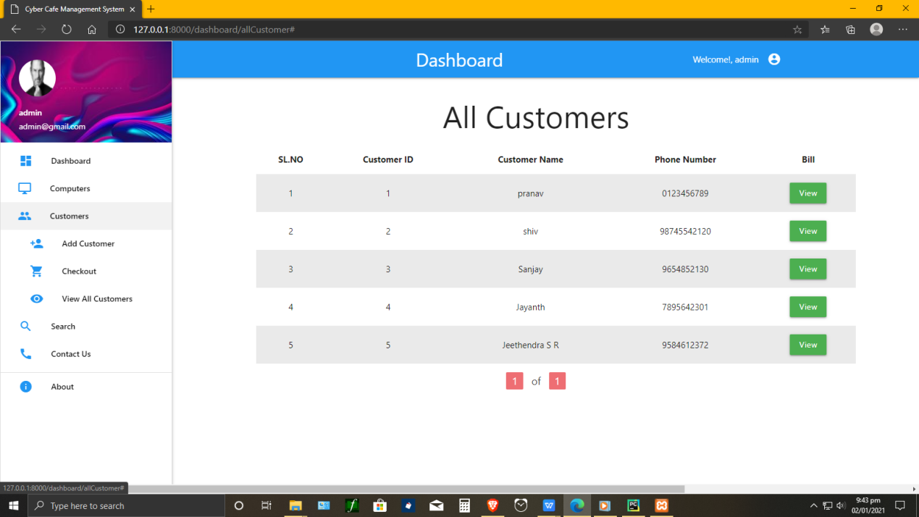

**Checkout**

In order to generate the bill of the customer, admin has to checkout for his out-time. Thus, generating a bill for the customer to pay.

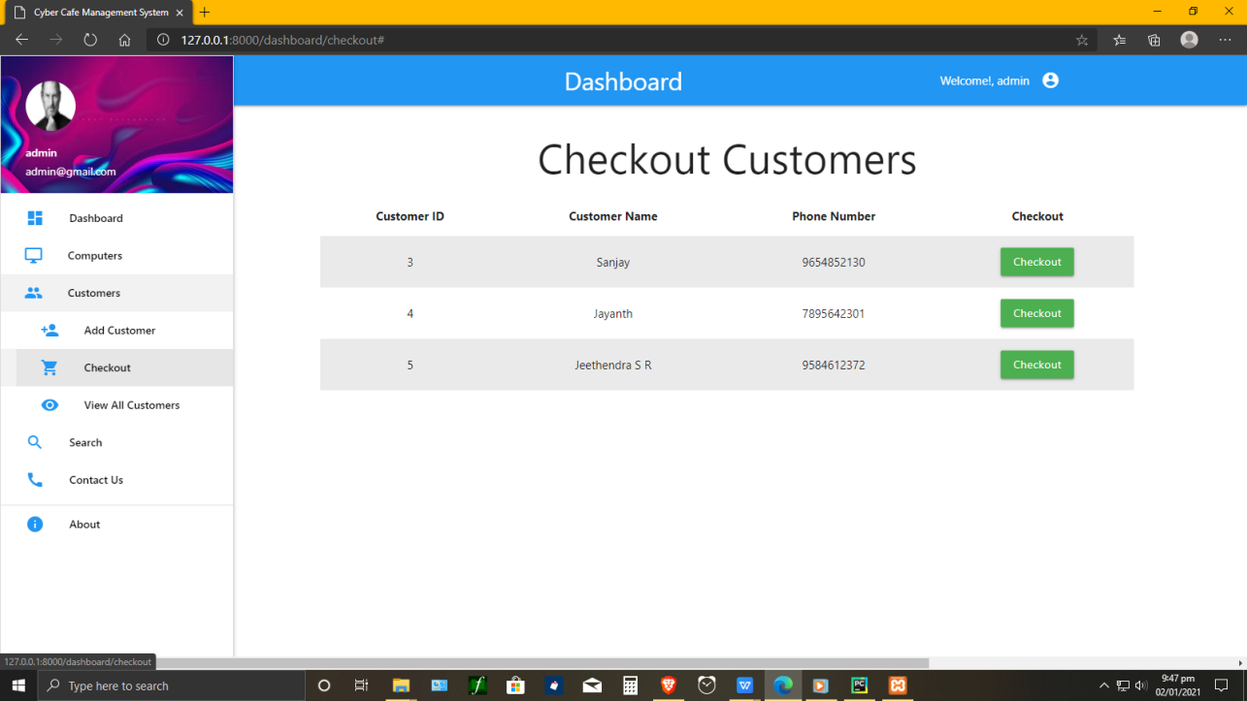

**Search**

This page allows the admin to search for the customers and Report.

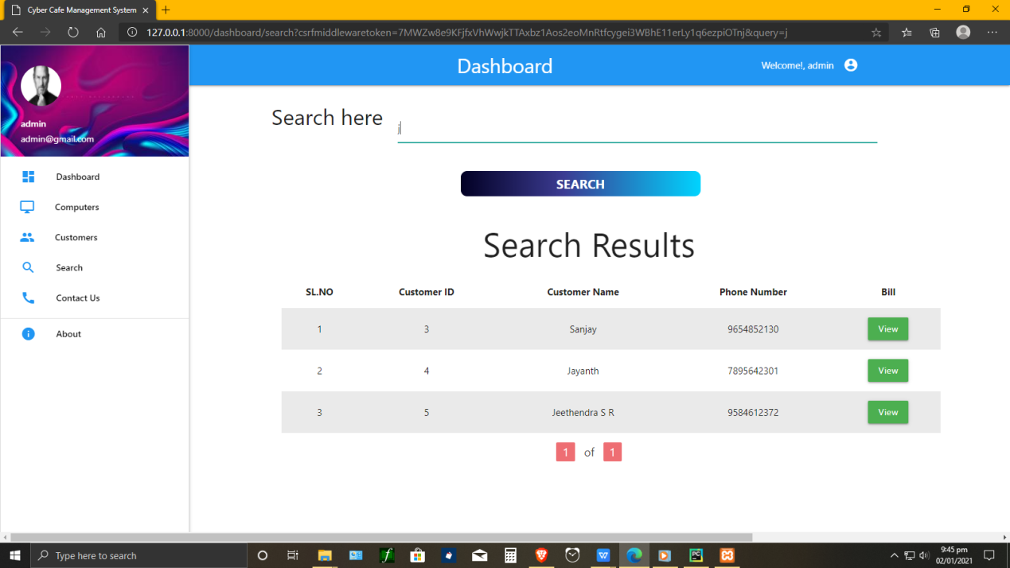

**Profile info**

This page let’s admin to setup his/her profile. It includes admin’s Username, First name, Lastname, Email to fill and update. Admin can also add his/her photo for display by choosing the path of the file.

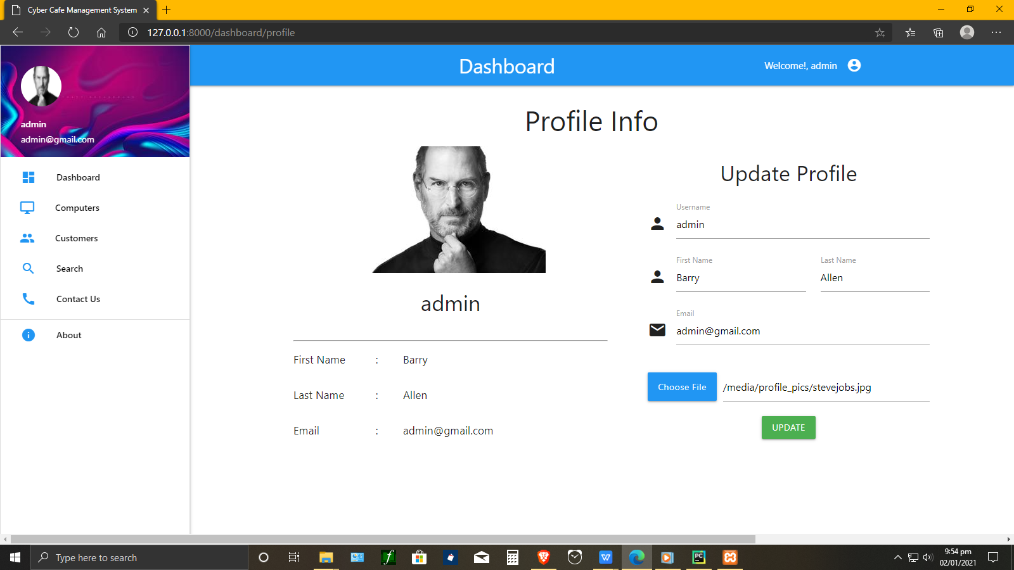

**CONCLUSION**

* Cyber Cafe management system provides the ease to the owner to distribute the customer to different terminals in best possible way and to know when the session is complete.
* Its major advantage is that it records the type of terminals accessed by the customers and full details of the customers are recorded in the database so that if any enquiry is needed by anyone later it can be systematically done.
* It works the admin front so user cannot manipulate or access any part of the information in the system.
* the time allotment is done very efficiently and it provides fast service in term of the bill calculation and time management.

**REFERENCES**

* Fundamentals of Database Systems(7th Edition) - Ramez Elmasri and Shamkant B. Navathe
* https://docs.djangoproject.com/en/3.1/intro/
* https://youtube.com/playlist?list=PLebdnM09G8Kj8vgXsFjPuLaNoN7H3nHNM
* https://en.wikipedia.org/wiki/Internet_caf%C3%A9
* https://www.academia.edu/38153262/Cyber_Cafe_Management_System_Project_Report
* https://github.com/topics/dbms-project
* https://w3points.com/django-tutorial/
* https://stackoverflow.com/questions/20575809/django-tutorial